  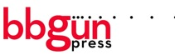
  For Immediate Release
  Contact:
  Bobbie Gale
  BB Gun Press
  323-904-9094
  Bobbie@bbgunpress.com
  Jamie Garabedian
  Vagrant Records
  323-302-0100 ext. 232
  Jamie@vagrant.com
  Tour Press:
  Shannon Cosgrove
  BB Gun Press
  323-904-9094
  Shannon@bbgunpr.com
  www.bbgunpress.com

ALBERT HAMMOND JR. ANNOUNCES THIRD ALBUM,
MOMENTARY MASTERS

NEW SONG 'BORN SLIPPY' STREAMABLE/SHAREABLE VIA SOUNDCLOUD

PRE-ORDER MOMENTARY MASTERS TODAY

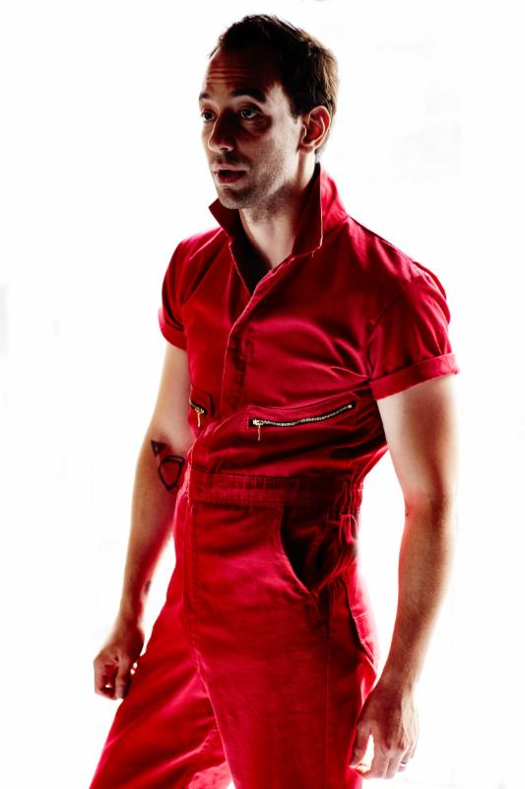

(May 12, 2015) - Today, Albert Hammond Jr. is pleased to share plans to release his third solo album, and first in five years, entitled Momentary Masters. The album's name derives from a phrase in astronomer Carl Sagan's Pale Blue Dot: A Vision of the Human Future in Space - a notion that underscores the truism that every triumph is fleeting.

"I feel like the best songs I've written, as soon as I was done, I was like, 'Oh my God, I did it!' But in that split second that it comes, that feeling goes," Hammond Jr. explains. "It's the same thing when you find complete happiness, you find this complete low. I feel like that's what being creative is: It's you bouncing with emotion and what you capture in those bounces. Accept where you are and use it." And Albert has done just that. In a recent interview with Paper Mag, Hammond Jr. discusses his new domesticity and it's influence on his third record. "He's cleaned up, gotten hitched, and moved from the city to upstate New York, but hasn't lost the ability to create soaring rock riffs and catchy hooks."

Due to drop on July 31st in the US via Vagrant/BMG, Momentary Masters serves as a follow up to 2006's Yours To Keep and 2008's ¿Cómo Te Llama? "We're huge fans of Albert Hammond Jr.'s and are excited to be working with him on his best effort yet," says Jon Cohen EVP of Recorded Music for Vagrant/BMG.

Recorded in Hammond Jr.'s home in upstate New York in a converted barn he calls One Way Studios, Albert created Momentary Masters alongside guitarist Hammarsing Kharhmar (Mon Khmer), guitarist Mikey Hart (Bleachers), bassist Jordan Brooks, and drummer Jeremy Gustin (Delicate Steve, Marc Ribot). The sessions were extremely relaxed which encouraged space for creativity and collaboration. The result offers a new kind of dynamism: you can hear it in "Power Hungry," with its Morricone-esque grooves and a Mellotron manipulated to sound like violins; or in the aggressive stomp and anxiety-inducing guitars of "Caught By My Shadow." Even on "Side Boob" - titled so because, hey, why not celebrate a good thing? - there's a jittery energy that leaves the listener excited.

Momentary Masters is a record that reflects on missed opportunities, choices made, wasted time, and paths not chosen. He calls it "a love letter to my past self." The music might be largely buoyant-spry, breezy guitar lines locking together and dancing apart - but melancholy frequently seeps into even the sunniest of toplines. It's a record of acceptance, too. Tucked in the songs is an exploration of the reconciliation of two halves: the best self that you present to others, and the self that slips through and lies exposed when your guard drops.

Today, fans can get a taste of Momentary Masters by streaming the album track "Born Slippy" on Soundcloud.

Albert Hammond Jr. will be on tour in North America from the beginning of September until the beginning of November. All dates (except fests) are on pre-sale beginning today directly via Albert's website. A full list can be found below.

All Pertinent Links:
Song 'Born Slippy' on Soundcloud HERE
Preorder on iTunes HERE
Preorder on Amazon HERE
Preorder on Albert's Store HERE
Purchase tickets HERE

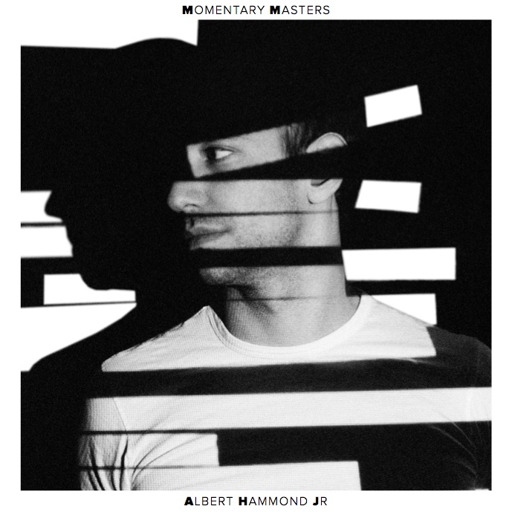

Momentary Masters Track List
1. Born Slippy
2. Power Hungry
3. Caught By My Shadow
4. Coming To Getcha
5. Losing Touch
6. Don't Think Twice, It's Alright
7. Razors Edge
8. Touche'
9. Drunched In Crumbs
10. Side Boob

Albert Hammond Jr. On Tour
May 27 Barcelona, Spain @ Primavera Sound
September 09 Pittsburgh, PA @Brillobox
September 10 Cleveland, OH @ The Grog Shop
September 12 St. Louis, MO @ Loufest
September 13 Lawrence, KS @The Bottleneck
September 15 Chicago, IL @ Bottom Lounge
September 16 Detroit, MI @ Shelter
September 17 Toronto, ON @ The Opera House
September 19 Montreal, QC @ La Sala Rossa
September 20 Cambridge, MA @ The Sinclair
September 21 New York, NY @ The Bowery Ballroom
September 26-27 Washington DC @ Landmark Festival
September 29 Atlanta, GA @ The Earl Restaurant & Lounge
September 30 Nashville, TN @ Exit In
October 02 New Orleans, LA @ One Eyed Jacks
October 02-04 Austin, TX @ ACL Festival
October 05 Houston, TX @ HOB Bronze Peacock
October 06 Dallas, TX @ HOB Cambridge Room
October 07 Norman, OK @ Opolis
October 08 Little Rock, AK @ Juantias
October 9-11 Austin, TX @ ACL Festival
October 12 Phoenix, AZ @ Crescent Ballroom
October 13 Santa Ana, CA @ The Observatory - Constellation Room
October 14 Los Angeles, CA @ Teragram Ballroom
October 16 San Francisco, CA @ The Independent
October 25 Seattle, WA @ The Crocodile
October 26 Vancouver, BC @ Venue
October 27 Portland, OR @ Doug Fir Lounge
October 29 Salt Lake City, UT @ Urban Lounge
October 30 Aspen, CO @ Belly Up Aspen
October 31 Denver, CO @ Lost Lake
November 02 Des Moines, IA @ Vaudeville Mews
November 03 Minneapolis, MN @ Triple Rock
November 04 Madison, WI @ High Noon Saloon
November 06 Columbus, OH @ The Basement
November 07 Philadelphia, PA @ First Unitarian Church

https://instagram.com/alberthammondjr

###

