Black Joe Lewis Announce Track Listing For Electric Slave
Out August 27 Via Vagrant Records

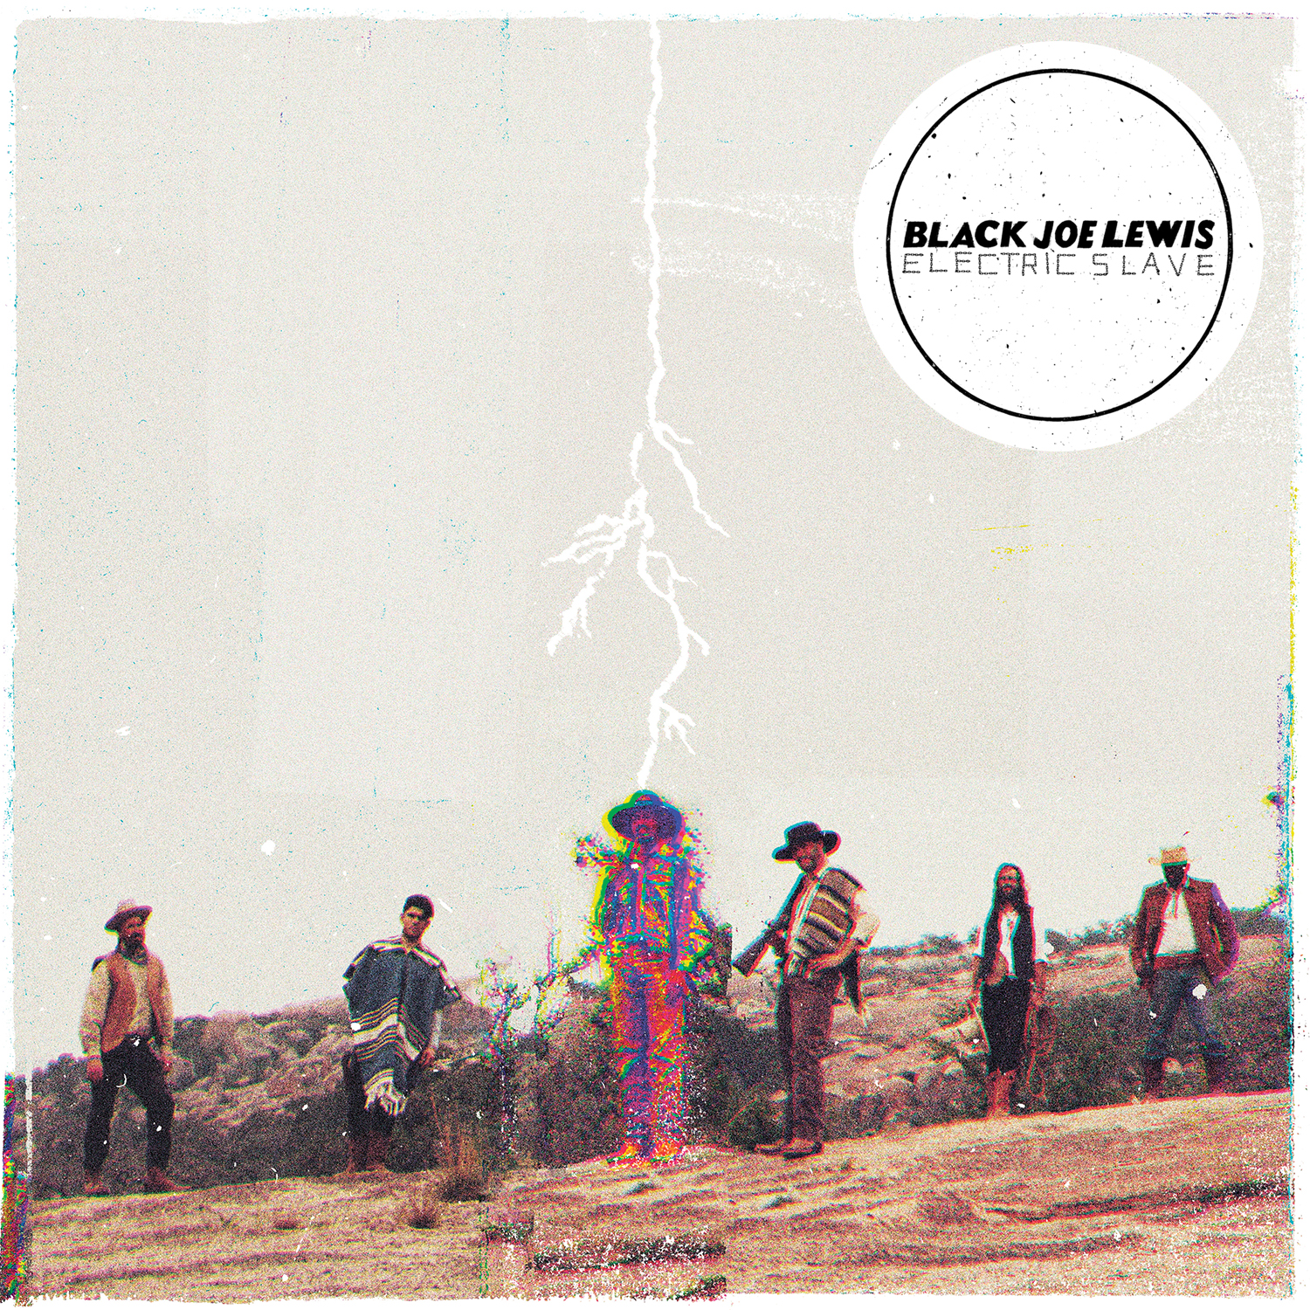

Black Joe Lewis have unveiled the track listing and album art for their brand new full-length LP, Electric Slave, to be released on August 27 on Vagrant Records. Check out the album art above and the track listing below. You can listen to the album’s opening track “Skulldiggin” at the link here:

http://soundcloud.com/black-joe-lewis/skulldiggin/

“Skulldiggin” was hailed by Consequence of Sound as “a deafening first shot in the band’s war against technology-induced devolution. Over the mortar fire of crashing cymbals and the bombastic wail of a ferocious guitar, Lewis screams and shouts about mind control. And when his voice gets swallowed up by the feedback, it’s an intriguing extension of the anti-technology commentary.”

Most of Electric Slave was produced by GRAMMY award winner Stuart Sikes (White Stripes, Cat Power, Modest Mouse) and recorded at Church House Studios in Austin, TX. Three of the new tracks (“Skulldiggin,” “Dar Es Salaam,” “My Blood Ain't Runnin' Right”) were recorded and produced by John Congleton (Explosions in the Sky, St. Vincent, Okkervil River) at Elmwood Studios in Dallas.

The band will tour supporting Electric Slave beginning in September, playing a number of shows along the east coast including a show at New York’s Terminal 5 on September 26. For complete itinerary, please see below.

Electric Slave
1. Skulldiggin
2. Young Girls
3. Dar es Salaam
4. My Blood Ain't Runnin' Right
5.Guilty
6. Come To My Party
7. Vampire
8. Make Dat Money
9. The Hipster
10. Golem
11. Mammas Queen

BLACK JOE LEWIS ON TOUR
Jun 26 - Austin, TX KGSR “Blues on the Green” at Zilker Park Set Time: 8:15p
July 14 Sun Cincinnati, OH “Bunbury Music Fest”
Sept 7 Nashville, TN @ Mercy
Sept 8 Atlanta, GA @ Terminal West
Sept 9 Charleston, SC @ Pour House
Sept 10 Carrboro, NC @ Cat's Cradle
Sept 12 Boston, MA @ Royale
Sept 13 Portland, ME @ Port City Music Hall
Sept 14 Fredricton, NB @ Harvest Blues Festival
Sept 15 Halifax, NS @ Seahorse Tavern
Sept 18 Montreal, QC @ La Sala
Sept 19 Toronto, ON @ Lee's %
Sept 20 Ithaca, NY @ The Haunt %
Sept 22 Philadelphia, PA @ Union Transfer %
Sept 26 New York, NY @ Terminal 5 #
Sept 28 Cleveland, OH @ Grog Shop %
Sept 30 Milwaukee, WI @ Turner %
Oct 1 Minneapolis, MN @ First Avenue %
Oct 2 Lincoln, NE @ Bourban Theatre %
Oct 3 Norman, OK @ Univ of Oklahoma %

% = w/ Pickwick
# = w/ Okkervil River, Pickwick

Website: http://www.blackjoelewis.com/
Facebook: https://www.facebook.com/blackjoelewis
Twitter: https://twitter.com/blackjoelewis

For press inquiries, please contact:

Jim Merlis
Big Hassle Media
jim@bighassle.com

